

**Software Engineering and Testing. BSC Year 2, 2024/2025**

**Software Engineering and Testing. BSC Year 2, 2024/2025 (Assignment 4 - 25%)**

**Assignment 4: Software Testing**

**Submitted by:**

**RUBEN SOB B00166481**

**EMI HERDMAN B00165844**

**FRANKLIN OTWAMOAHENE ADDO B00159369**

**Submission date**

**28/04/2025**

**Declaration**

I hereby certify that this material, which I now submit for assessment on the programme of study leading to the award of Ordinary Degree in Computing in the Institute of Technology Blanchardstown, is entirely my own work except where otherwise stated.

Author: Ruben Sob Dated: 28/04/2025

Author: Emi Herdman Dated: 28/04/2025

Author: Franklin Otwamoahene Addo Dated: 28/04/2025

**Assignment 4: Software Testing**

1. **User Interface Testing**

User Interface test that will be done on our project include, minimal user clicks, feedback, consistency, recoverability and also user guidance.

* Consistency

Same header and footer used across all pages. Also, Uniform button styles (Buy Now, Back, Go to Product Page) as well as colour scheme and typography consistent.

* Feedback

Success and error messages displayed to the customers when the does something correct or error. The messages will be in simple English for all customers to understand.

* Recoverability

Customers can remove and update the cart that is adding and removing products, also customers remove mistakenly added products. Customers can go to another page and the cart will still have the products added.

* Minimal user clicks

When customers click on a brand logo directs them to a filtered product list. Also, buy now button on the home page sends customers to the product page or the checkout page. Also, the minimal clicks for a customer to purchase something on the website is 5 clicks depending on the page the customer is at the time.

* User guidance

There is placeholder text in search bar for customers to know that they can use it to search for products. Also, there are proper labels on buttons ("Buy Now", "Go to Product Page"). Section headers clearly describe the content on the website.

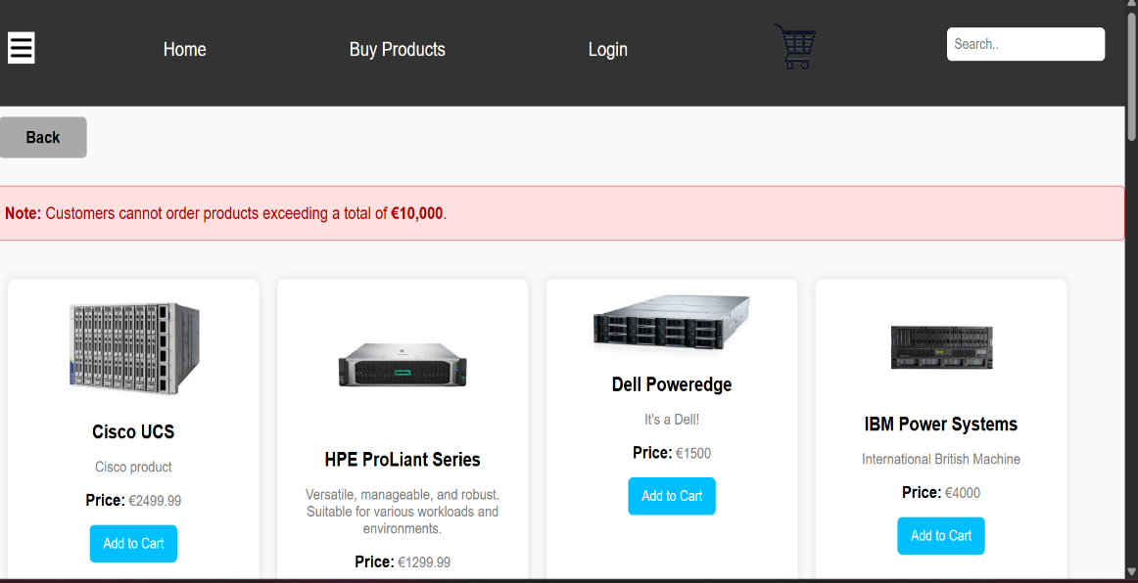

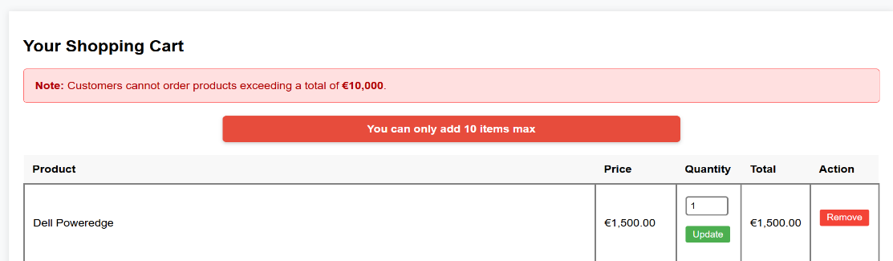

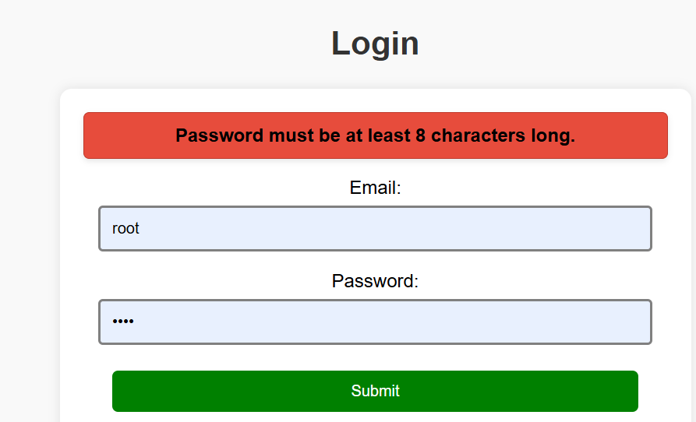

1. **Requirements Testing**

**Use case specification checklist ( completed ).**

* At the start of the project, we included in our use case specifications that a customer can purchase a product on the website, that is completed.
* Use case specifications specified that a customer can view history of their purchases made on the website and it is completed.
* Use case specifications specified that a customer can sell his electronic products on the website and it is completed.
* Use case specifications specified that a customer can view website pages.

**Use case specification checklist ( not completed ).**

* Use case specification specified that a customer can get a sale on products during seasonal times, it is not completed.

1. **Validation Testing**

The validation test was done couple of features of the project.

* Users are allowed to a password more than 8 characters when creating an account.
* Users are not allowed to create an account unless a customer is at least 15years old.
* Admin cannot set product price to negative price.
* Users cannot purchase more than 10000 worth of products .
* Users cannot purchase 10 of the same products during the transaction process.

1. **Unit Testing**

Unit testing of the project was done on user, admin as well as product. A php file of the unit testing is added to the project folder.